Extension of Time and Loss & Expense Narrative #: Loading Bay

A. Introduction
- This narrative sets out the Contractor’s (ULS) entitlement arising out of delays caused by the changes to and restrictions on the size and use of the loading bay on Chesnut Road.
- The change to the loading bay was a Change under clauses 5.1.2.1 or 5.1.2.2 of the Contract and constituted a Relevant Event under clauses 2.26.1 and/or 2.26.6 and a Relevant Matter under clauses 4.21.1 and/or 4.21.5 respectively.

B. Summary
- ULS was originally provided with a longer loading bay which could accommodate two vehicles being unloaded by two tower cranes at the same time, as set out in the Contract.
- However, after the Works had been carried out for around 8 months, the loading bay was changed and shortened so that it could only be used by one vehicle at a time (unloaded by one tower crane).
- The effective halving of the unloading capacity caused significant delays to the deliveries and, as a result, the progress of the Works.

C. Position under the Contract
- As part of the Employer’s Requirements, item 58 of the Schedule of Employer’s Accepted Items (SEAIs) referred to the TTMO (Temporary Traffic Management Order) drawing rev 1 dated 12 March 2020 (TTMO Plan).
- The sub-folder for Item 58 “Site Logistics” included the following documents: (a) the TTMO Plan, (b) an agreed delivery plan and (c) a draft final Construction Logistics Plan (CLP).
- The TTMO Plan (extracted below) showed a 44.2m vehicle unloading bay for deliveries on Chesnut Road to the north of the site:
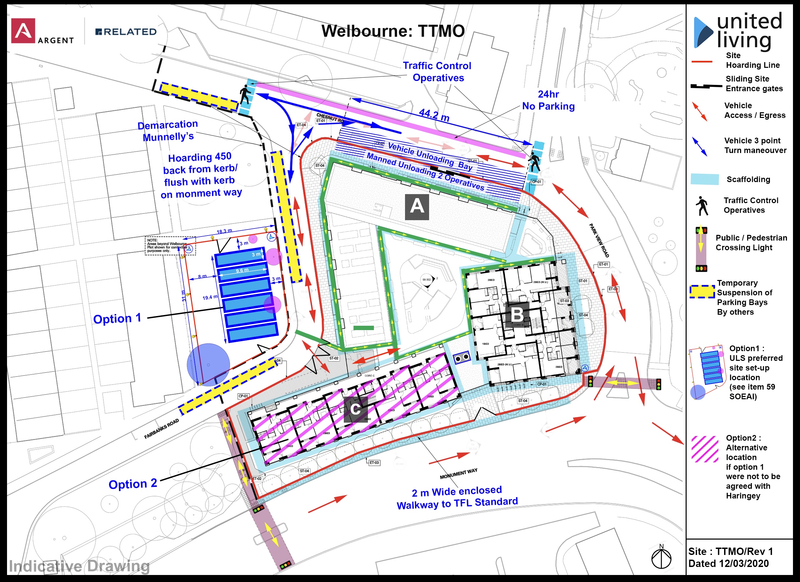
- The draft CLP also included two copies of the TTMO Plan on pages 7 and 13. Paragraph 3.1.4 of the draft CLP confirmed that “During the construction phase the project will be serviced by two tower cranes.” [Albeit this seems to be focused on erection not delivery]
- In summary, under the Contract, there was to be a Loading Bay on Chesnut Road long enough to accommodate two vehicles at the same time, which could be unloaded simultaneously by two tower cranes.
- On 25 March 2020, the Haringey (Chestnut [sic] Road) (Temporary Prohibition And Restriction Of Traffic) Order 2020 came into force. The existing permanent loading bay (marked by white lines) on Chesnut Road was suspended and the south side of Chesnut Road (10 metres from its junction with Fairbanks Road to 10 metres from its junction with Park View Road – long enough for two vehicles) could only be used for loading and unloading vehicles for the Works.
- When ULS commenced Works in May 2021, it was provided with and used this two vehicle Loading Bay on Chesnut Road and unloaded vehicles from the loading bay with two tower cranes.

D. Change
- On 16 February 2021, Haringey Council sent an email to ULS alleging that a tower crane was operating outside of the loading bay and, if it continued to do so, the TTMO would be removed halting all deliveries to the site.
- On 25 February 2021, Haringey Council emailed ULS stating that it needed an oversail licence for the tower cranes.
- On 1 March 2021, ULS submitted an application for an oversail licence for the two tower cranes.
- On 2 March 2021, Haringey Council’s Traffic Management Officer (Frank Daly) emailed ULS and the Highway Licences department of the Council stating that the oversail licence should not be granted because there was no traffic management drawing showing the loading bay as limited to the permanent loading bay marked (i.e. the loading bay marked with white lines which had been suspended by the TTMO) on Chesnut Road.
- On 2 March 2021, Jake Whiterod of THDM emailed Mr Daly explaining that ULS “has been clear all the way through that it requires a full layby on Chesnut road, as per the attached plan which was I understand was part of the CEMP and TTMO submission”. Mr Whiterod further explained that “[h]aving reviewed what I understand to be the Temporary order from LBH which came into force on 25th March I am a bit confused as it seems to support” the fact that a longer two vehicle loading bay had been requested by ULS and granted by Haringey Council.
- At a meeting on 3 March 2021, with THDM and ULS, Haringey Council, however, now stated that ULS could not unload vehicles outside the existing permanent loading area and the loading bay would be reduced accordingly.
- Later that month, Haringey Council issued an oversail licence. The licence only permitted one tower crane to oversail the highway to unload from the loading bay. The second tower crane was only permitted to load and unload within the site. Even if an oversail licence had been granted for both tower cranes, the second crane still could not have been used to unload from the reduced loading bay because the tower cranes would have impeded each other in trying to lift from a single vehicle in the shorter loading bay.
- In summary, the reduction to the length of the loading bay meant that only one vehicle could be unloaded at any one time, by only one crane. The second tower crane became a slave crane, only able to take materials from the other crane rather than directly from vehicles.

E. Legal Basis of the Claim
- The change to the loading bay was a Change under clauses 5.1.2.1 or 5.1.2.2. There was an addition or alteration of obligations or restrictions imposed in the Employer’s Requirements in regard to access to the site or use of any specific parts of the site (the loading bay being part of the site) and limitations of working space.
- The change to the loading bay was a change or a matter to be treated as, or as requiring, a Change. As a result the reduction to the loading bay amounted to a Relevant Event and Relevant Matter under clauses 2.26.1 and 4.21.1 respectively.
- The change to and reduction of the loading bay also amounted to a Relevant Event and Relevant Matter under clauses 2.26.6 and 4.21.5 respectively in that it was caused by an impediment or prevention of THDM:
  - The longer loading bay and the TTMO was initially approved by Haringey Council in March 2020 on the basis that THDM was going to provide a pit lane (i.e. holding area for vehicles waiting to make deliveries) on Monument Way in order to prevent traffic disruption caused by vehicles backing up at the loading bay on Chesnut Road.
  - However, in June 2020, THDM informed ULS that it had “pushed back” on Haringey Council’s request for a pit lane on Monument Way. THDM did not attempt to or in fact obtain such a pit lane.
  - Haringey Council’s subsequent reduction of the loading bay appears to have been because of THDM’s failure to obtain or progress with a pit lane to Monument Way.
  - This failure was an act of prevention or impediment by THDM.

F. Impact of the Change
- The reduction and change to the loading bay, so that only one vehicle could be unloaded at a time with only one tower crane directly unloading from the vehicle, caused significant delays to the Works.
- The reduced capacity to unload significantly delayed and extended the time required for deliveries.
- [Can we add some colour/detail to the impact/ delay caused by the loading bay?]
- [We should provide a summary of the total delay and the total L&E which we say was caused by the Loading Bay, If possible separating between prolongation, thickening, and any subcontractor claims]

United Living (South) Limited
January 2025

Article 14 of the Contract confirms that the TTMO plan is part of the Employer’s requirements, referring to “the plan (reference TTMO/Rev1 dated 12/03/2020) included in the Employer’s Requirements”.

